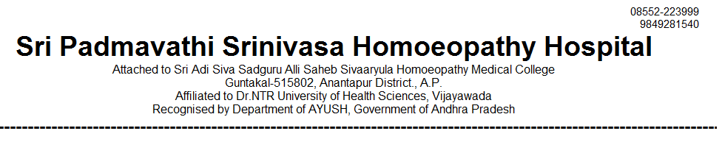
OUT PATIENT STATEMENT FOR THE YEAR JAN-2021 TO DEC - 2021

SNO | MONTH | GENERAL MEDICINE | GYNAECOLOGY /OBSTERICIAN | PAEDIATRICS | SURGERY | TOTAL
1 | 2021 - JAN | 1826 | 1299 | 894 | 265 | 4284
2 | 2021 - FEB | 2836 | 1506 | 1103 | 561 | 6006
3 | 2021 – MAR | 3166 | 1615 | 1216 | 578 | 6575
4 | 2021 – APR | 2791 | 1428 | 1064 | 494 | 5777
5 | 2021 – MAY | 517 | 254 | 166 | 71 | 1008
6 | 2021 – JUN | 476 | 271 | 216 | 116 | 1079
7 | 2021 – JUL | 1600 | 881 | 632 | 272 | 3385
8 | 2021 – AUG | 2871 | 1458 | 1046 | 485 | 5860
9 | 2021 – SEP | 3008 | 1521 | 1123 | 624 | 6276
10 | 2021 - OCT | 2923 | 1473 | 1119 | 603 | 6118
11 | 2021 - NOV | 3057 | 1532 | 1169 | 651 | 6409
12 | 2021 - DEC | 3291 | 1587 | 1269 | 631 | 6778
